DEPARTMENT OF CHEMISTRY
PROFILE
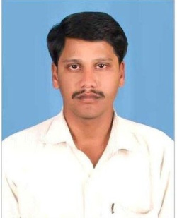
1.NAME: KASTURI VENU GOPAL
2. DESIGNATION : LECTURER
AND PLACE OF WORK : IDEAL COLLEGE OF ARTS AND SCIENCES(A)
KAKINADA-533003, E.G.Dt.
AP., INDIA.
3. DATE OF BIRTH : 01-07-1980
4. NATIONALITY : INDIAN
5. MOBILE NUMBER : 9493646120
6.E-MAIL :venugopalkasturi1980@gmail.com
7. ADDRESS FOR COMUNICATION: K VENU GOPAL
IDEAL COLLEGE OF ARTS AND SCIENCES(A)
KAKINADA-533003
AP., INDIA.
8.DETAILS OF EDUCATIONAL QUALIFICATIONS:

S.NO | COURSE | UNIVERSITY | YEAR | SPECILIZATION
1 | MSc | ANDHRA UNIVERSITY | 2005 | ANALYTICAL CHEMISTRY
2 | B.Ed | ANDHARA UNIVERSITY | 2002 | PHYSICAL SCIENCES

9. EXPERIENCE:

S.NO | DESIGNATION | NAME OF THE COLLEGE | DATE OF JOINING | EXPERIENCE
1 | LECTURER | RAJEEV GANDHI COLLEGE, KAKINADA | 20-08-2005 | 3 YEARS
2 | LECTURER | IDEAL COLLEGE OF ARTS AND SCIENCE, KAKINADA | 20-08-2008 | 9 YEARS

10. REGIONAL /STATE/NATIONAL LEVEL CONFERENCES/ WORK SHOPS/ SEMINARS:

A) MODERN ASPECTS OF SPECTROSCOPIC TECHNIQUES, 27-02-2016
B) MODERN ASPECTS OF ORGANIC SPECTROSCOPIC TECHNIQUES, 10-02-2017

11. ADMINISTRATIVE EXPERIENCE:
NIL

12. TRAINING PROGRAMS /COURSES ATTENDED: NIL

